**LINUX BASIC COMMANDS AND THEIR OUTPUT:**

1. lscpu

Interpretation:

display information about the CPU architecture

Output:

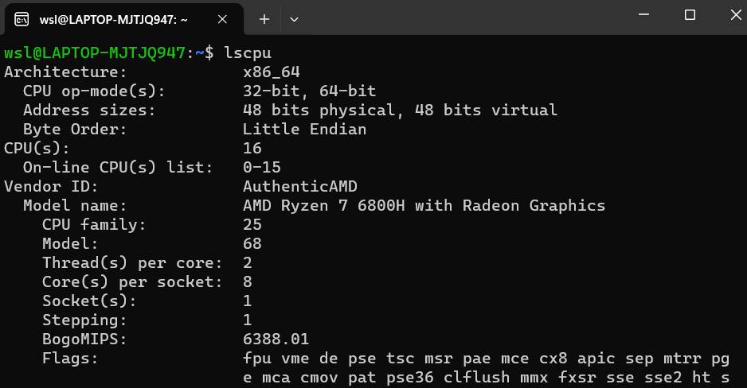

2. lshw

Interpretation:

extract detailed information on the hardware configuration of the machine.

Output:

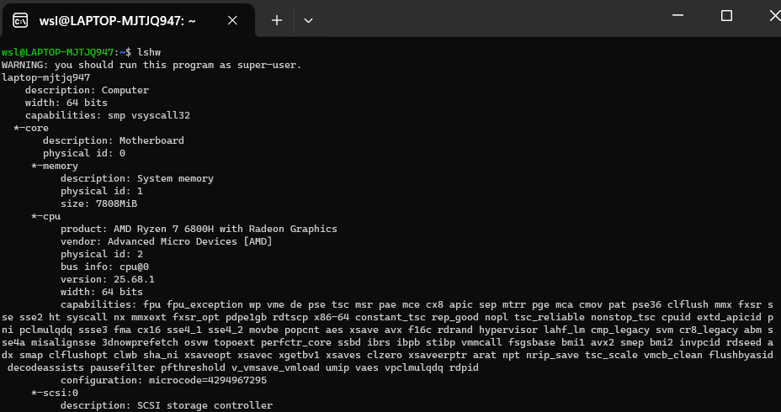

3. sudo lshw

Interpretation:

extract detailed information on the hardware configuration of the machine.

Output: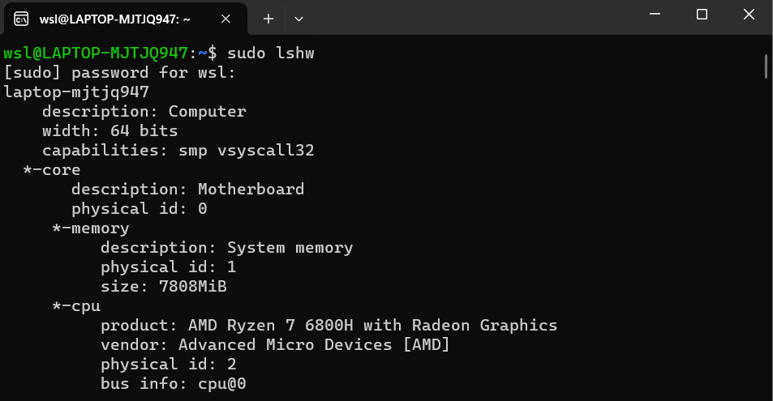

4. lspci

Interpretation:

displays information about PCI buses in the system and devices connected to them

Output:

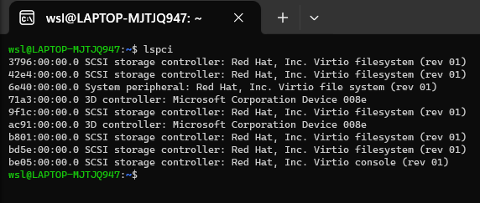

5. lsscsi

Interpretation: list SCSI devices (or hosts) currently attached to the system.

Output:

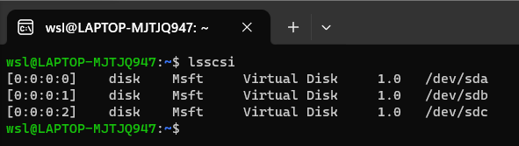

6. lsusb

Interpretation:

displays information about USB buses in the system and the devices connected

to them. It uses udev's hardware database to associate a full human-readable name

to the vendor ID and the product ID.

Output:

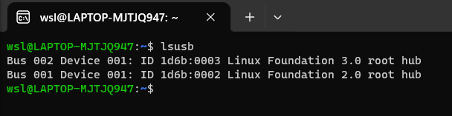

7. lsblk

Interpretation:

lists information about all available or the specified block devices.

Output:

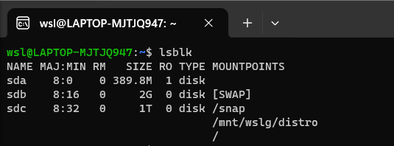

8. df

Interpretation:

displays the amount of space available on the file system containing each file

name argument. If no file name is given, the space available on all currently mounted

file systems is shown.

Output:

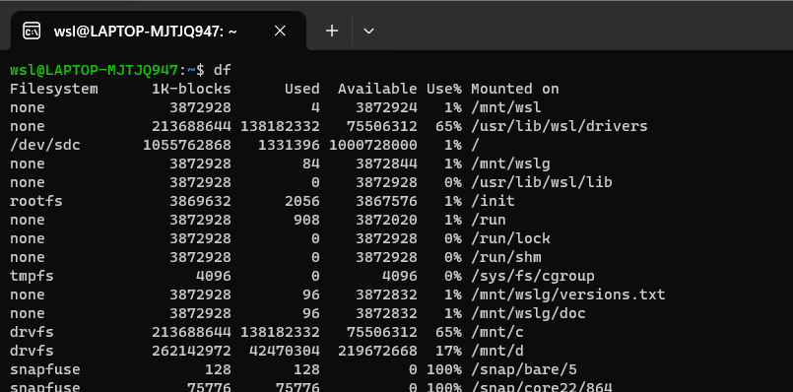

9. free

Interpretation:

Display amount of free and used memory in the system

Output:

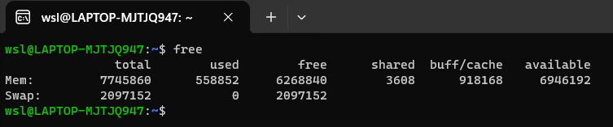

10. cat /proc/cpuinfo

Interpretation:

read the file /proc/cpuinfo to output the processor’s information like cpufamily,

model, microcode, flags, address sizes, cache_allignments,etc.

Output:

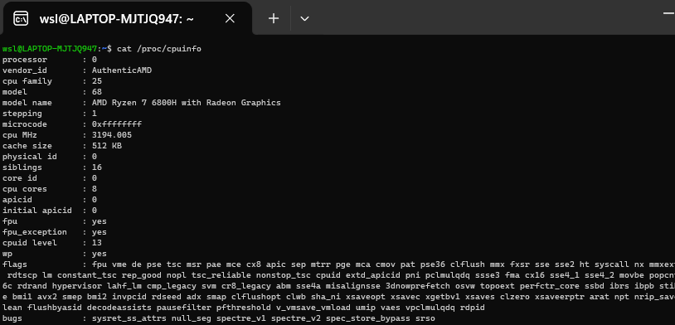

11. cat /proc/meminfo

Interpretation:

reads file /proc/meminfo and output the various information of memory segments

of the computer system

Output:

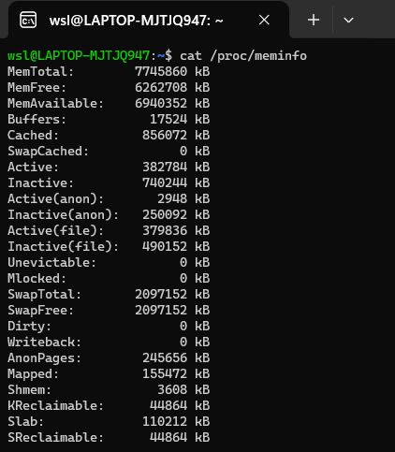

12. uname

Interpretation:

prints the system information

Output:

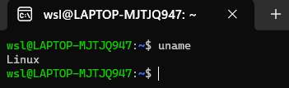

13. uname -n

Interpretation:

prints the network node hostname

Output:

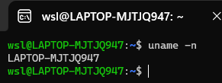

14. uname -v

Interpretation:

print the kernel version

Output:

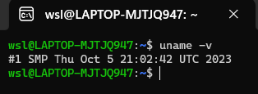

15. uname -r

Interpretation:

print the kernel release

Output:

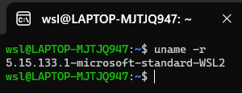

16. uname -m

Interpretation:

print the machine hardware name

Output:

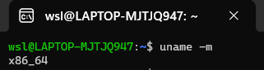

17. uname -a

Interpretation:

print all informations like kernel name,network node hostname, kernel release

and version,machine hardware name, processor type,etc.

Output:

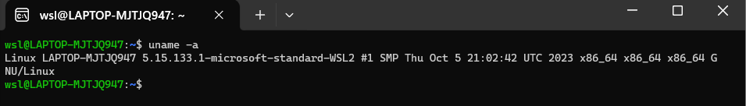

18.

factor 1203343

Interpretation:

print the prime factors of the given numbers, either given from command line

or read from standard input

Output:



19. echo ‘3*9’| bc

Interpretation:

echo displays the string passed and ‘|’ symbol is used to redirect the output

of echo to arbitrary precision calculator language bc to produce the product of

3 and 9

Output:

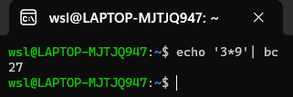

20. echo ‘(6*5)-8’| bc

Interpretation:

calculates the give expression and displays in the terminal

Output:

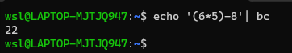

21. id

Interpretation:

print real and effective user and group IDs

Output:



22. lsusb | tee lsusb.txt

Interpretation:

lsusb outputs all the usb devices and ‘|’ symbol redirects the output of lsusb

into file lsusb.txt

Output:

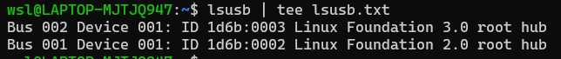

23. cat lsusb.txt

Interpretation:

reads the file lsusb.txt

Output:



24. shutdown

Interpretation:

schedule the shutdown of the system after one minute

Output:



25. shutdown now

Interpretation:

power-off the machine instantly

Output:



26. shutdown 13:20

Interpretation:

This command shuts down the machine at 13:20

Output:



27. shutdown 10

Interpretation:

schedule the shutdown of the system after ten minutes

Output:



28. shutdown -r +10

Interpretation:

schedule the reboot of the system after ten minutes.



29. shutdown -c

Interpretation:

Cancel a pending or scheduled shutdown.

Output:



30. ping -w 3 google.com

Interpretation:

send ICMP ECHO_REQUEST to google.com

Output:

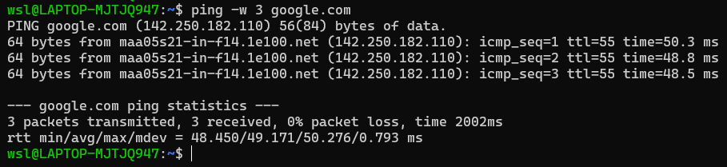

31. netstat

Interpretation:

Print network connections, routing tables, interface statistics, masquerade

connections, and multicast memberships

Output:

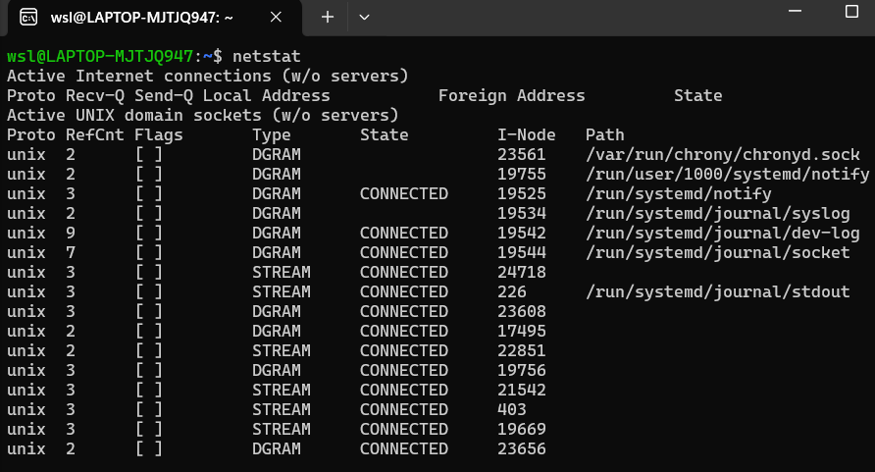

32. netstat -r

Interpretation:

Display the kernel routing tables.

Output:

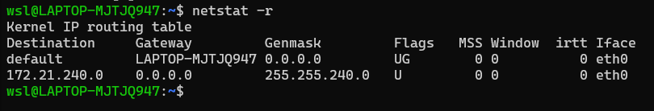

33. netstat -p

Interpretation:

Show the PID and name of the program to which each socket belongs. A hyphen

is shown if the socket belongs to the kernel (e.g. a kernel service, or the process

has exited but the socket hasn't finished closing yet).

Output:

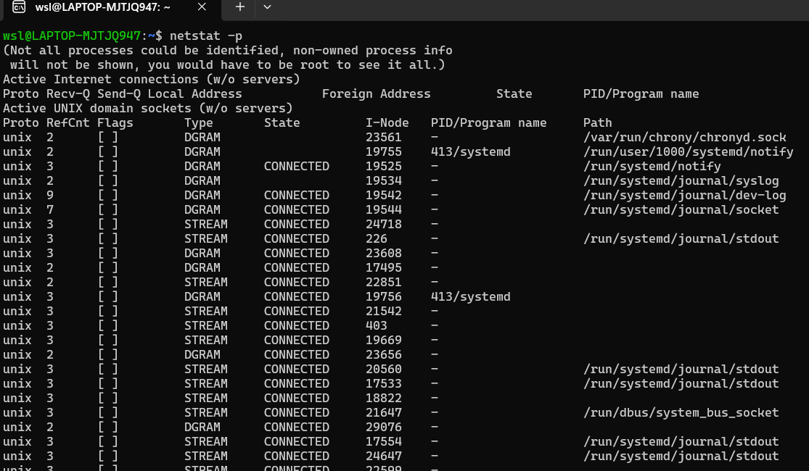

34. host google.com

Interpretation:

performs DNS lookups. It is normally used to convert names to IP addresses and

vice versa.

Output:

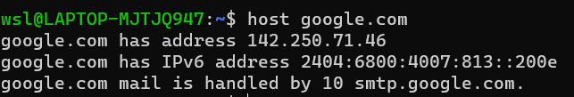

35. tracepath achsnepal.edu.np

Interpretation:

traces path to a network host discovering MTU along this path

Output:

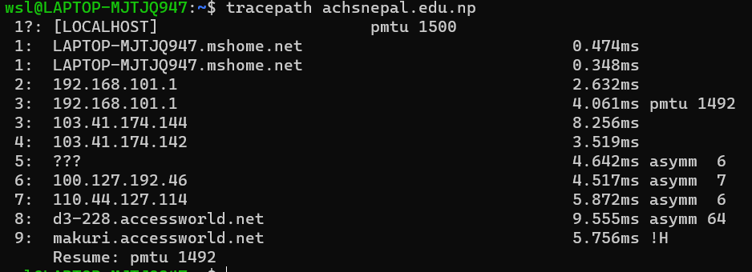

36. ifconfig

Interpretation:

displays the status of the currently active interfaces.

Output:

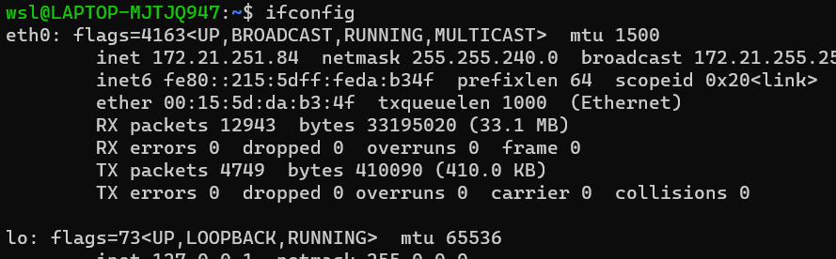

37. route

Interpretation:

show / manipulate the IP routing table

Output:

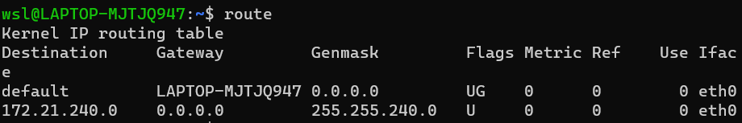

38. nslookup achsnepal.edu.np

Interpretation:

query Internet domain name servers interactively

Output:

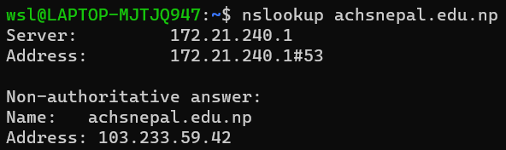

39. whois brainyquote.com

Interpretation:

guess the right server to ask for the specified object. If no guess can be made

it will connect to whois.networksolutions.com for NIC handles or whois.arin.net

for IPv4 addresses and network names.

Output:

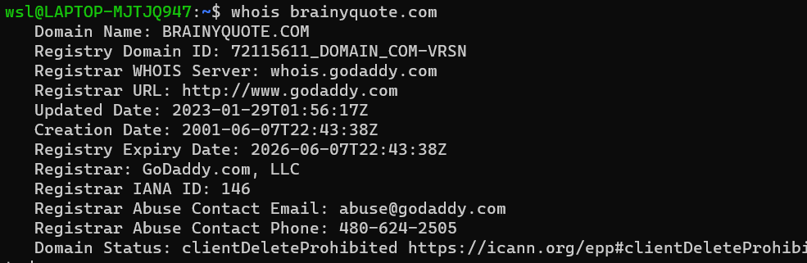

40. sudo apt-get update

Interpretation:

resynchronize the package index files from their sources.

Output:

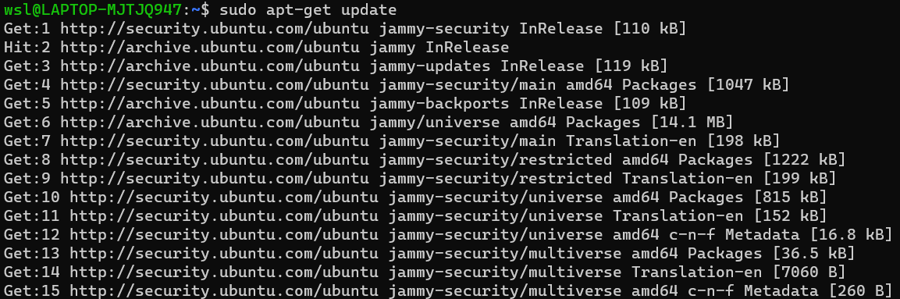

41. sudo apt-get install sl

Interpretation:

install package sl

Output:

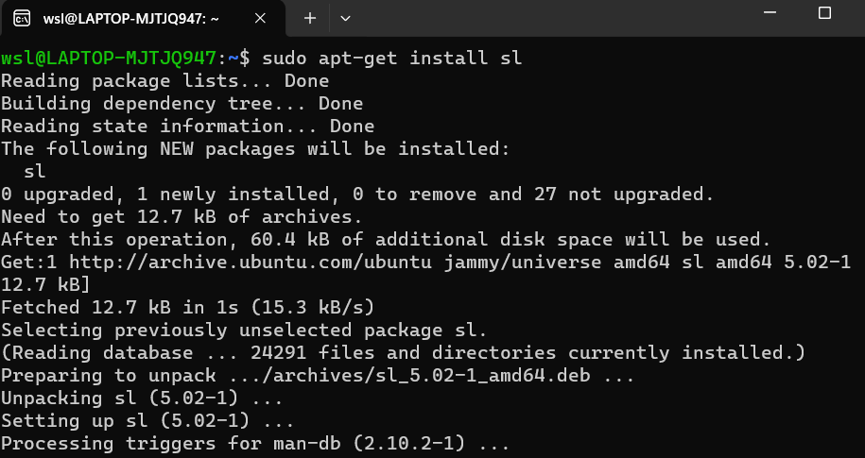

41. sl

Interpretation:

display animations aimed to correct users who accidentally enter sl instead of

Output: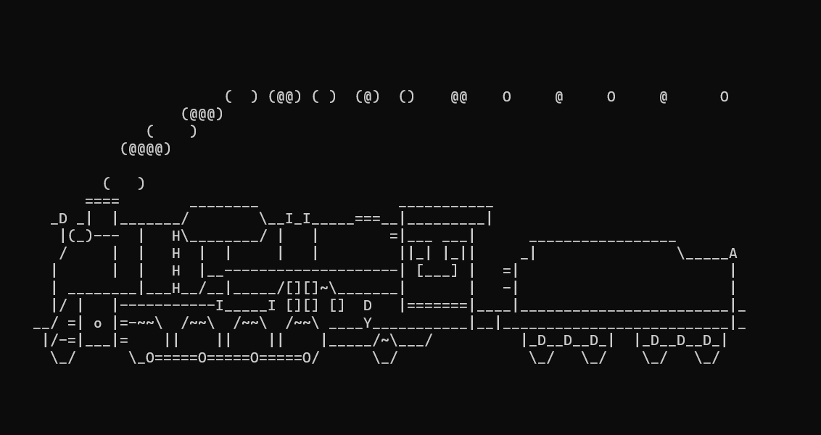

42. sudo -s

Interpretation:

Run the shell specified by the SHELL environment variable if it is set or the

shell specified by the invoking user's password database entry.

Output:



43. exit

Interpretation:

exit the current program

Output:

